Quiz # 3(Section B)
Formal Methods 20/3/2025
Name: ---------------------- Roll No:-------------------------
For the following UML Class Diagram, write down constraints in OCL. (Total Points= 16, 2 points each)

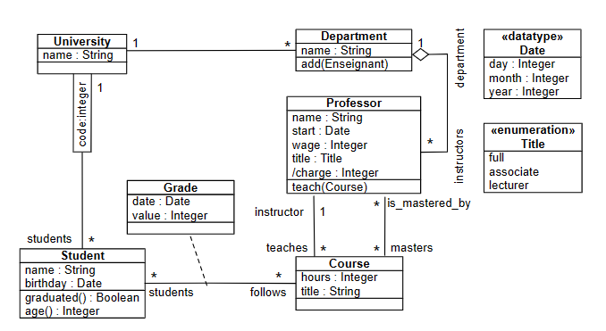
departments
university
- A department's university should not be null.
- A university must have at least one department
- A student average grade is always greater than 4:
- There is at least one student named 'Ali' in the university
- If the title of the Professor is ‘full’ he teaches at least three courses.
- The wage of all instructors in a departments is at least 100,000 PKR.
- A student cannot follow more then three courses at a time

